Lab 18 : Iceberg Lifecycle Management & Cost Monitoring

Table of Contents
Table of Contents 2
Introduction 3
Learning Objectives 3
Prerequisites 3
Part 1 — Inspecting Hidden Metadata for Costs 4
Part 2 — The "Orphan Files" Threat 6
Part 3 — Removing Orphaned Files 6
Knowledge Check 9
Troubleshooting 9
Symptom: remove_orphan_files didn't find my dummy file. 9
Conclusion 9

Introduction
Streaming massive amounts of data into an S3 or GCS bucket is incredibly cheap—until you stop managing it.
If a Spark Streaming job crashes halfway through writing a micro-batch, it leaves behind "orphan files". These files are physically sitting in your storage bucket, costing you money every month, but Iceberg's metadata doesn't know they exist, so standard expire_snapshots maintenance jobs will never clean them up!
In this lab, you will learn how Platform Engineers monitor Iceberg costs by querying Iceberg's hidden metadata tables. You will also execute advanced lifecycle management procedures to hunt down and delete unreferenced orphan files.

Learning Objectives
Upon completing this lab, you will be able to:
- Query Iceberg's hidden .files and .snapshots metadata tables.
- Calculate table storage footprints programmatically.
- Understand how failed streaming writes generate orphan files.
- Execute the remove_orphan_files stored procedure.

Prerequisites
- Completion of Module 10 labs(You must have the PySpark/Iceberg environment and warehouse/ directory set up).

Part 1 — Inspecting Hidden Metadata for Costs
Iceberg provides powerful "hidden" tables that allow you to query the internal state of your Lakehouse using standard SQL. This is how organizations build Dashboards to track cloud storage costs.
Create a monitoring script:
cd ~/iceberg-labs
monitor_costs.py

Paste the following code:
from pyspark.sql import SparkSession
import os
spark = SparkSession.builder \
.appName("IcebergCostMonitor") \
.config("spark.jars.packages", "org.apache.iceberg:iceberg-spark-runtime-3.5_2.12:1.5.0") \
.config("spark.sql.extensions", "org.apache.iceberg.spark.extensions.IcebergSparkSessionExtensions") \
.config("spark.sql.catalog.local", "org.apache.iceberg.spark.SparkCatalog") \
.config("spark.sql.catalog.local.type", "hadoop") \
.config("spark.sql.catalog.local.warehouse", f"{os.getcwd()}/warehouse") \
.getOrCreate()
print("1. Querying active snapshots:")
spark.sql("""
SELECT committed_at, snapshot_id, operation, summary['added-files-size'] as added_bytes
FROM local.db.lakehouse_events.snapshots
ORDER BY committed_at DESC LIMIT 5
""").show(truncate=False)
print("2. Calculating Total Active Storage Footprint (Bytes):")
# The .files table lists every single physical Parquet file actively managed by the current snapshot
spark.sql("""
SELECT SUM(file_size_in_bytes) as total_active_bytes, COUNT(file_path) as total_files
FROM local.db.lakehouse_events.files
""").show()
spark.stop()

Run the script:
python3 monitor_costs.py

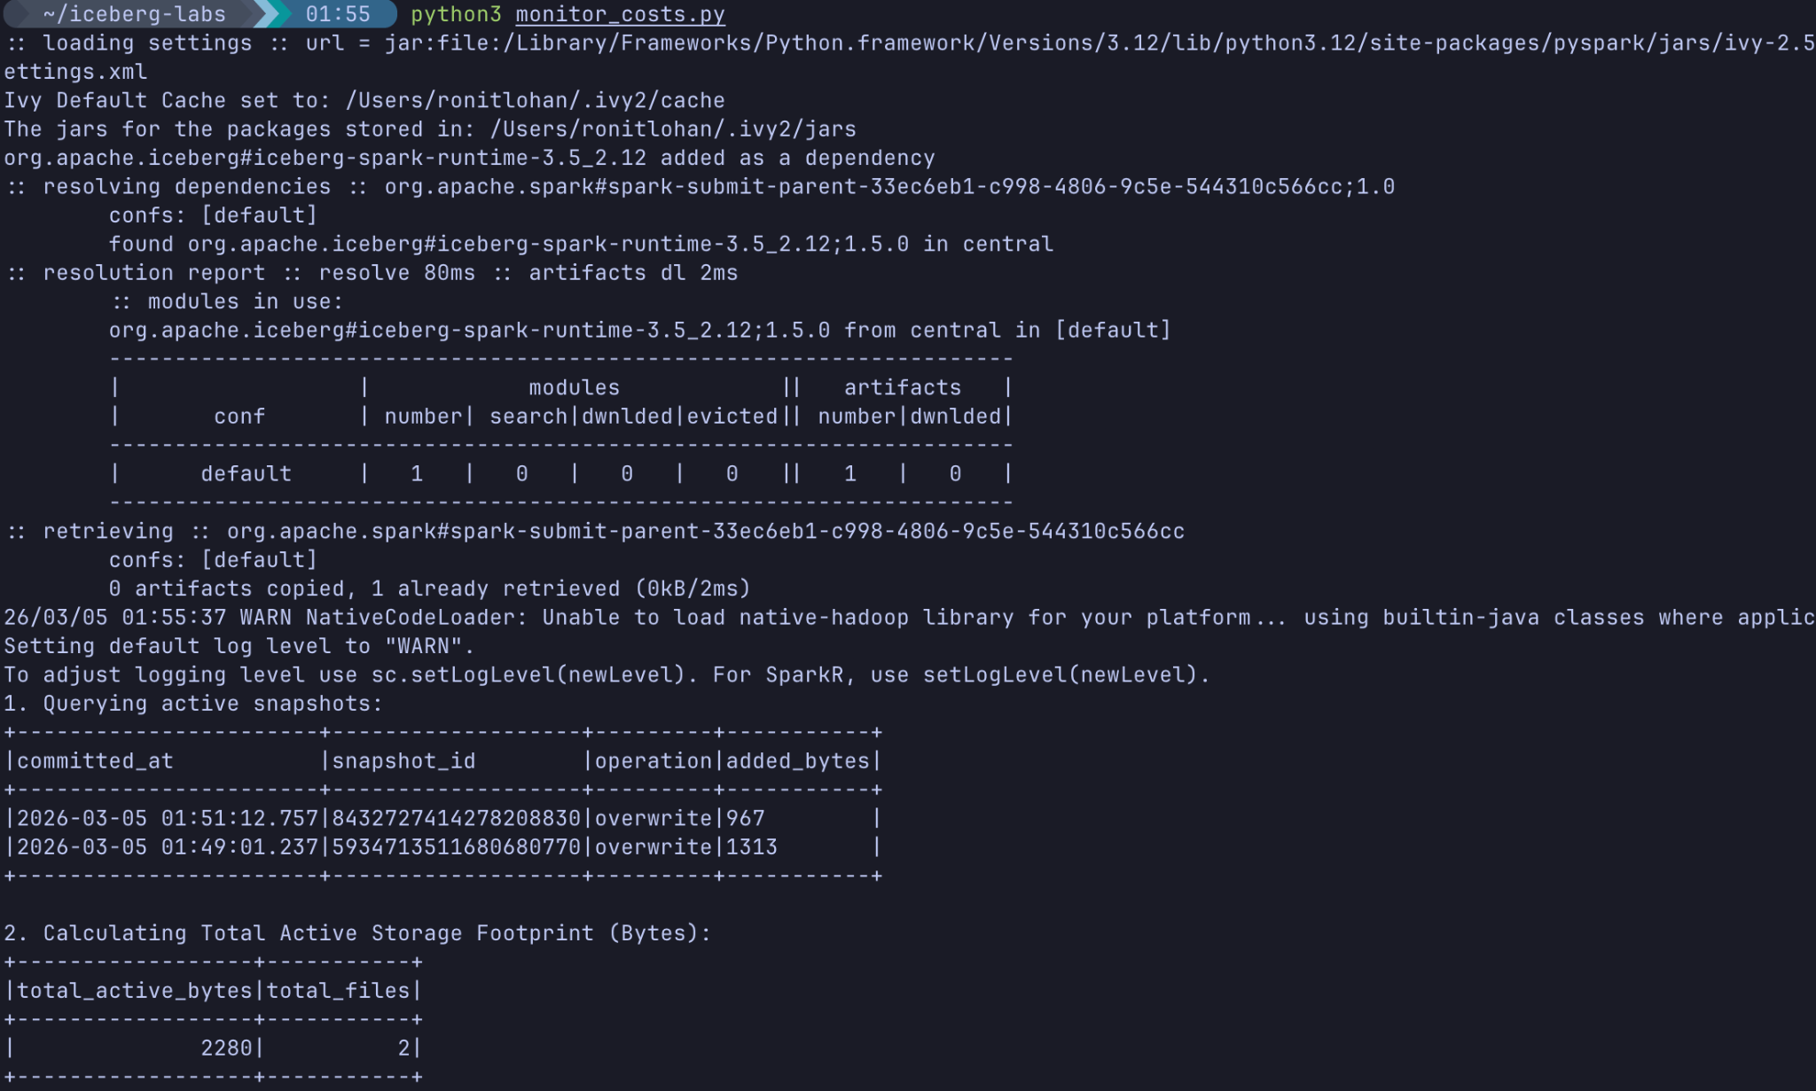
What you will see: You can track exactly how many bytes were added by recent micro-batches, and get a precise count of the total physical bytes the current table occupies. Platform teams run queries like this against information_schema equivalents to trigger alerts if a table grows unexpectedly fast.

Part 2 — The "Orphan Files" Threat
When PySpark writes a streaming micro-batch to Iceberg, it follows two steps:
- It physically writes the .parquet files to the disk/S3.
- It attempts to commit the transaction to metadata.json.
If the Spark node crashes, loses network, or hits an OOM (Out Of Memory) error after step 1 but before step 2, the .parquet files are successfully written, but Iceberg has no idea they exist!
Let's simulate this manually by writing a junk file into our Iceberg data directory.
Create a fake "crashed" parquet file in the Iceberg data directory

touch warehouse/db/lakehouse_events/data/crashed_batch_001.parquet

If you query SELECT SUM(file_size_in_bytes) FROM local.db.lakehouse_events.files again, it will not count this file, because the file isn't in the metadata! However, your AWS S3 bill absolutely will charge you for it.

Part 3 — Removing Orphaned Files
To fix this, Iceberg provides a built-in procedure that scans the entire physical directory, compares the files against the metadata manifests, and systematically deletes any files that are not supposed to be there.
Create the cleanup script:
remove_orphans.py

Paste the following code:
from pyspark.sql import SparkSession
import os
import time
spark = SparkSession.builder \
.appName("IcebergOrphanCleanup") \
.config("spark.jars.packages", "org.apache.iceberg:iceberg-spark-runtime-3.5_2.12:1.5.0") \
.config("spark.sql.extensions", "org.apache.iceberg.spark.extensions.IcebergSparkSessionExtensions") \
.config("spark.sql.catalog.local", "org.apache.iceberg.spark.SparkCatalog") \
.config("spark.sql.catalog.local.type", "hadoop") \
.config("spark.sql.catalog.local.warehouse", f"{os.getcwd()}/warehouse") \
.getOrCreate()
print("1. Bypassing the 24-hour Orphan Safety Lock...")
# Iceberg explicitly prevents deleting orphan files created within the last 24 hours.
# We will use Python to artificially backdate our physical files by 4 days!
data_dir = f"{os.getcwd()}/warehouse/db/lakehouse_events/data"
if os.path.exists(data_dir):
four_days_ago = time.time() - (4 * 24 * 60 * 60)
for root, dirs, files in os.walk(data_dir):
for file in files:
if file.endswith('.parquet'):
os.utime(os.path.join(root, file), (four_days_ago, four_days_ago))
print("Successfully aged physical files by 4 days.")
print("2. Running Remove Orphan Files Procedure...")
# Now we can safely run the default procedure, which automatically cleans orphans older than 3 days.
spark.sql("""
CALL local.system.remove_orphan_files(
table => 'db.lakehouse_events'
)
""").show(truncate=False)
spark.stop()

Run the cleanup job:
python3 remove_orphans.py

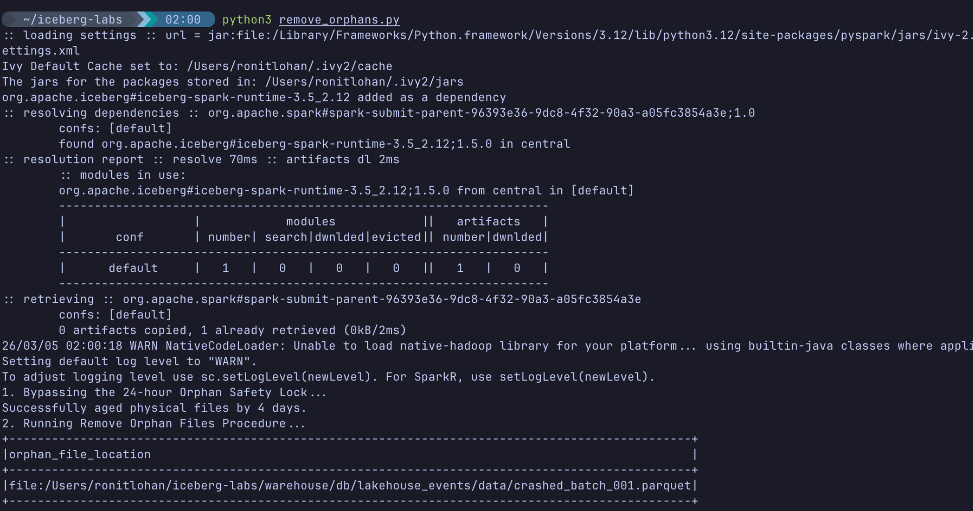
Expected Output: The Spark job will output a dataframe showing the exact path of the crashed_batch_001.parquet file it successfully detected and deleted.
You can verify the file was actually removed from your filesystem by running:
ls warehouse/db/lakehouse_events/data/crashed_batch_001.parquet

Output: No such file or directory

Knowledge Check
- Why does a standard expire_snapshots job not clean up orphan files?
  - Answer: expire_snapshots only cleans up files that were previously tracked by Iceberg's metadata but are no longer needed. Orphan files were never successfully registered in the metadata, so Iceberg ignores them unless explicitly told to search the physical directory.
- Why does remove_orphan_files default to only deleting files older than 3 days?
  - Answer: If it deleted files instantly, it might accidentally delete .parquet files that are currently being written by a perfectly healthy streaming job that just hasn't committed its metadata yet.
- How can you find out exactly how much physical storage an Iceberg table is using?
  - Answer: By querying the hidden <table_name>.files metadata table and summing the file_size_in_bytes column.

Troubleshooting

Symptom: remove_orphan_files didn't find my dummy file.
Solution: Ensure you created the dummy file inside the exact physical data/ directory of the table (warehouse/db/lakehouse_events/data/). Also ensure you passed the future timestamp (older_than => TIMESTAMP '2099-01-01') to override the 3-day safety threshold.

Conclusion
In this lab, you mastered the lifecycle economics of a Streaming Lakehouse. You learned that operating pipelines at scale requires more than just writing data; it requires diligent monitoring of hidden metadata tables to track costs, and ruthless execution of cleanup procedures like remove_orphan_files to ensure your cloud storage footprint remains pristine and cost-effective.

